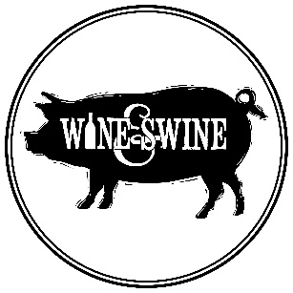
White & Rosé Wines

Opstal Blush Syrah | Viognier | 95
Quando Mourvèdre Rosé | 95
Domaine Des Dieux Claudia Brut MCC | 265
Pop Song Sauvignon Blanc Sparkling Wine | 115
Haystack Chardonnay | 100
JH Meyer Palmiet | 225
Kleine Zalze Chardonnay | 135
River Garden Chardonnay | 80
Waterside Chardonnay | 70
Circumstance Chenin | 140
Joostenberg Chenin | 125
Opstal Chenin | 120
Painted Wolf Chenin | 95
The Beekeeper Chenin | 86
Delheim Gewurztraminer | 150
Spioenkop Riesling | 270
False Bay Windswept Sauv Blanc | 90
John B Sauv Blanc | 70
Kumusha Sauv Blanc | 75
Weather Station Sauv Blanc | 100
Klein Sering Semillon | 280
TSW Semillon | 320
French Quarter White Rhone Blend | 155
Haute Cabriere Chardonnay | Pinot Noir | 115
Klein Sering Semillon | Sauv Blanc | 280
Revenant White | 100
Reyneke Organic Sauv Blanc | Semillon | 105
Thorne & Daughters Rocking Horse | 285

