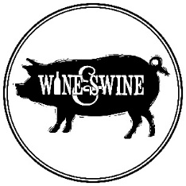
Red Wines

Rock Song Shiraz Sparkling | 115
Franschhoek Cabernet Sauvignon | 95
Painted Wolf Cabernet Sauvignon | 110
Peacock Wild Fermented Cabernet Sauvignon | 95
Revenant Red Cabernet Sauvignon | 100
Eveningstar Cinsault | 90
The Red Snapper Cinsaut | 86
Marras Piekenierskloof Grenache | 110
Mother Rock Grenache | 140
Franschhoek Merlot | 95
M·A·N Jan Fiskaal Merlot | 92
Peacock Wild Fermented Merlot | 95
The Mulberry Bush Merlot | 86
The House Martin Pinot Noir | 86
Thorne & Daughters Copper Pot | 160
False Bay Bush Vine Pinotage | 90
The Fat Man Pinotage | 100
Zewenwacht Zeven Pinotage | 75
False Bay Old School Syrah | 90
Leeuwenkuil Shiraz | 85
Painted Wolf Shiraz | 110
The Anvil Shiraz | 100
Weltervrede Cigar Box | 100
Anura Legato Cabernet Sauvignon | Merlot | 95
Anura Arpeggio SMV | 95
Anura Pinotage | Shiraz | 95
Doolhof Cape Boar Red | 90
French Quarter Rhone Blend | 155
John B Cab Sauv | Tinta Barocca | 70
Joostenberg Family Blend | 125
Opstal Cabernet Sauvignon | Cinsault | 120
Sixpence Cabernet Sauvignon | Merlot | 90
River Garden Shiraz | Merlot | 90
Reyneke Organic Shiraz | Cab Sauv | 105

